‘Residential Training’
Take time out to focus on training in tranquil, picturesque surroundings with excellent facilities and fully qualified 5* Eventing Coach Emilie Chandler.

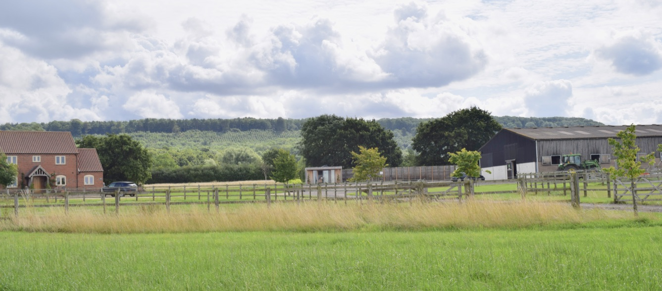

Our ‘Residential Training’ package is a great way to get the best training experience for you and your horse, be able to focus solely on your training and enjoy back to back sessions, including some ‘off the horse’ training sessions for goal setting, and planning.
Each package can be tailor made to suit you and your horse. Low Woods Farm can accommodate up to 4 horses for residential stays at any one time, so we can house a few people at the same time if needs.

Coaching is with UKCC Level 3 Eventing Coach Emilie Chandler. Emilie is an International Event Rider who has competed at 5* level on many occasions, has been a member of Team GB’s Eventing Nations Cup Squads and first reserve for the Senior European Eventing Championships in 2015. Emilie was then longlisted for the 2018 World Equestrian Games, the 2016, Olympics. She is currently longlisted for Tokyo Olympics 2020.

Emilie has vast experience as a coach, inspiring all levels of riders, and last year helped coach a rider to complete their first 5*. She is also helping coach the Team GB Show jumping Podium Potential squad this year, helping the show jumping riders with their flatwork and developing their horses as athletes.

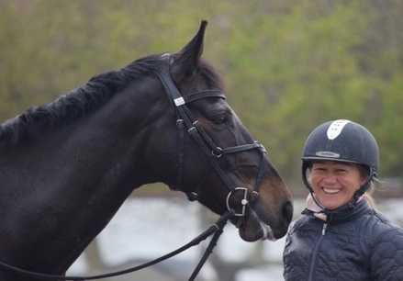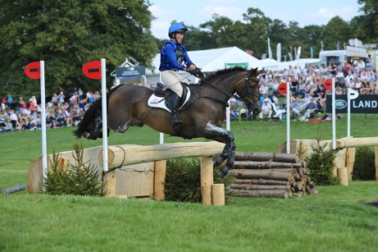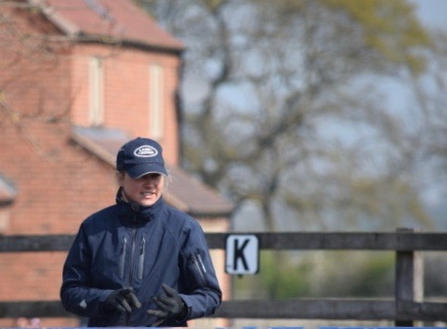

Low Woods Farm is set in the heart of The Vale of Belvoir, very close to Belvoir Castle. A tranquil setting for an enjoyable training experience. There is plenty of parking, American Barn style stabling with rubber matted boxes, automatic waters, and comfortable accommodation for you if required on site.
There is lovely off road hacking, and ‘The Engine Yard’ shopping village is 5 mins away if a change of scene is needed!

www.engineyardbelvoir.com

Private Riding Coaching Session
Each session will be focused on an area of the rider’s choice, for example; Dressage Training,
Flatwork with Cavaletti and pole exercises, Show Jumping training with a full course, or XC technique exercises.

Off Horse Coaching; ‘Poor Planning = Poor performance’
Book a slot to sit down with Emilie and make the most of an ‘off the horse’ session where she can discuss your ideas, and goals and help you make a structured detailed plan towards achieving them.
£30 for 45 mins.

Stabling
£25/ night, straw bed (one night) and £20/ night after that. Shavings are available on request at extra cost.

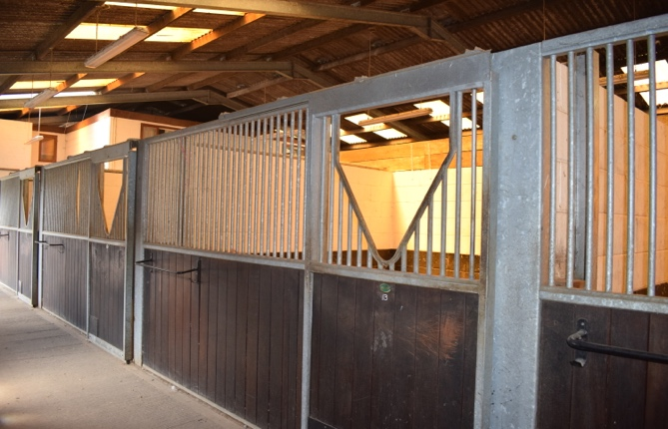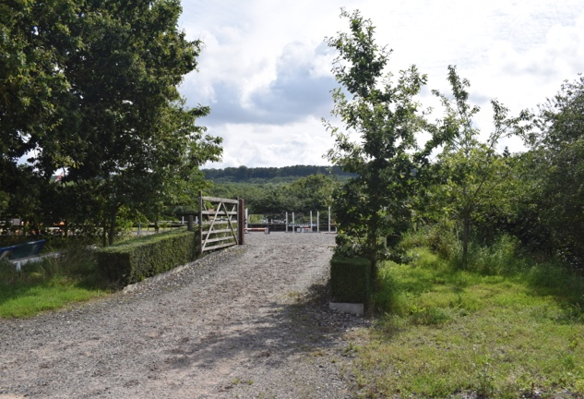

Accommodation for you:
This can be provided if required in ‘The Stables Flat’ at £25/ night per person. All bedding is provided, tea and coffee, but please bring your own food and drinks. There is a TV, Wifi, fridge/freezer, cooker, microwave.
There is 1 double room, and one twin room available in the flat.
You are welcome to stay in your lorry and electric hook up can be provided (see notes)

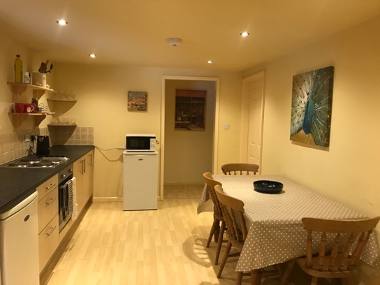
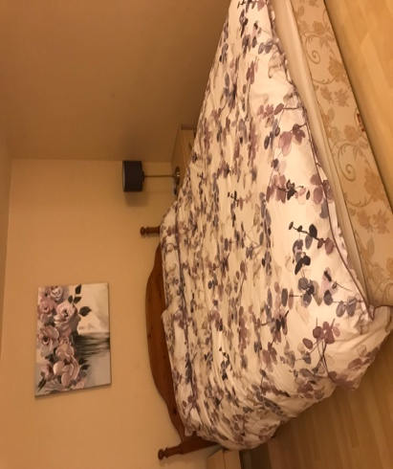

Please contact Emilie by email with your requirements
E: emschandler@hotmail.com

T: 07815 796647

Please note:

We can make packages to suit all durations of stay, and any number of lessons. Please discuss any option with Emilie.

You are entering a competition yard, so please inform Emilie of any skin conditions, vices or illness your horse may have as this may affect your ability to stay.
PLEASE PROVIDE PASSPORT ON ARRIVAL. FLU VACCINES SHOULD BE UP TO DATE. FAILURE TO DO THIS WILL MEAN YOU CAN NOT STABLE ON SITE.

Straw beds will be prepared for your arrival, but it is required that the stables are left clean with the straw up and all hay/feed removed and well swept.

Shavings can be bought on site for £9/bale but it will be up to you to prepare your own bed, alternatively you can bring your own type of bedding. If you use your own bedding or shavings then the bedding must be COMPLETELY REMOVED from the stable before you leave, and the stable left clean and well swept.

Haylage can be bought at £6/ night. We have NO HAY TO BUY ON SITE.
There are rubber mats in stables, and automatic water drinkers.

You are asked to not use the main yard tools or equipment and not to go in the tackroom or use the washbox/ tacking up area. There is a small washbox for visitors use, and a small tackroom for tack/ equipment which is separate to the main yard but conveniently situated next to the overnight stables.

Please do not walk through the main yard.

You can use the horse walker on request.

There will be no turnout available for visitors.

If you are staying in your lorry, there can be electric hook up at £8/night.

Payment Terms:

50% payment in advance for Lessons and stabling to secure booking. The remaining must be settled before leaving.
BACS payment or cash only. Sorry no cheques.
Bank details; 40-32-14 01424629

